**Blood Donation:**

[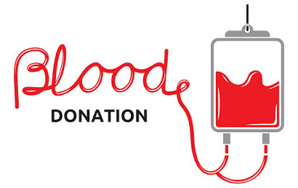](https://3.bp.blogspot.com/-eLCSywfhEOo/W8rpV7UWO6I/AAAAAAAAAW0/FSoqOEavUlwq7TeqQEmkuBiG7rYf19KOgCLcBGAs/s1600/1200-5480-blood-donation-photo1.jpg)

We often get sick for the lack of bloods. However many of us are recapped of the significance of blood donation when catastrophes happen, much of what we provide does the silent work of saving persons who’ll not ever show up on the bulletin. Since the necessity for blood doesn’t go missing, the best method to save lives is to donate regularly.

**Blood is a living tissue prepared  of blood cells**. They are Red blood cells (RBCs), a liquid called plasma that holds protein and  platelets and a quantity of other components. These three are the main components

**Red blood cells:**

[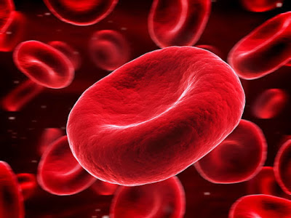](https://1.bp.blogspot.com/-Hc-lzRXbHgE/W8rpltEmKiI/AAAAAAAAAW4/zesN3yf3vm0wggw5epYkxYD99XNxK9lUwCEwYBhgL/s1600/red-blood-cells.jpg)

[RBCs](https://en.wikipedia.org/wiki/Red_blood_cell) hold **hemoglobin**, an iron-rich protein that transports **oxygen** and gives blood its rosy color.

**Plasma:**

[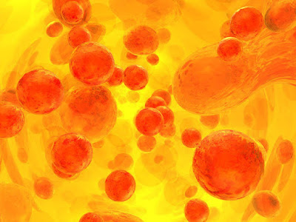](https://1.bp.blogspot.com/-d5GlTidAoEE/W8rp1rbMB6I/AAAAAAAAAXE/QGi0srY5Ics25Tijdzh5VChctm8nX9ITQCEwYBhgL/s1600/12_Plasma.jpg)

This yellow fluid in the blood transports the [RBCs](https://en.wikipedia.org/wiki/Red_blood_cell), platelets, and cells or proteins, similar to **antibodies**, that support fight with infections. **Cryoprecipitate** is the part of plasma that separates as freezing plasma gradually thaws. It comprehends a higher deliberation of blood-clotting proteins than consistent plasma. People with cancer do not frequently need transfusions of this portion of blood.

**Platelets:**

[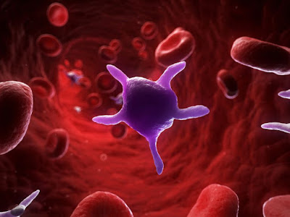](https://3.bp.blogspot.com/-G1dlF8sB724/W8rqacvmXqI/AAAAAAAAAXQ/qdF8C6oboeMFpRipv2k50wAalFcZx9ZOwCLcBGAs/s1600/activated-platelets--artwork-172592952-5a26f99289eacc003739b603.jpg)

These cells support form clots when we are bleeding. Thickening stops us from bleeding too much from an wound. When [platelets](https://en.wikipedia.org/wiki/Platelet) are little, serious or life-threatening bleeding can take place.

**Donating blood is safe:**

 There is no risk in getting **AIDS** or additional sicknesses from giving blood or blood products. Sterile, one-time-use non-refundable needles, tubing and gathering bags are used to safeguard you. **Registered nurses** who are especially qualified in blood collection will remain with you throughout the entire donation procedure.

[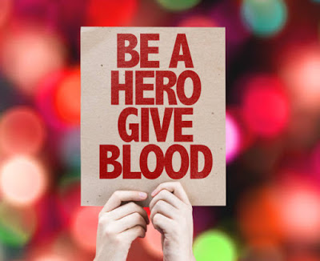](https://2.bp.blogspot.com/-PwoPO7zVgsg/W8rqw14JWEI/AAAAAAAAAXY/qxembsNVJKURyY05d-T04XnsAOe_qR1BQCLcBGAs/s1600/811434044-612x612.jpg)

**Side effects of blood donating:**

 Side effects as the consequence of blood donation are **exceptional**. The donor center nursing staff will teach you on any possible side effects that you could possibly experience. Fit people have an extra supply of red blood cells, platelets and plasma.

**Who can donate to whom:**

**If your blood type is:        You can provide to:                You can obtain from:**

A Positive                                     AB+,A+                          O+, O-, A+, A-

AB Positive                               AB+ Only                        All blood types

O Negative                              All blood types                       only  O-

B Negative                           B-, B+, AB-, AB+                       O-,  B-

AB Negative                            AB-, AB+                          AB-, A-, B-, O-

O Positive                             B+, AB+ , O+, A+                    O+, O-

B Positive                                 B+, AB+                           B+, B-, O+, O-

A Negative                         A+, AB-, AB+ ,A-                       O-, A-

**Eligibility for donatng:**

* Donator fit and well.
* Weigh above 7 stone 12 lbs or 50kg.
* Is aged in the middle of 17 and 66 (or 70 if you have given blood before).
* Is above 70 and have given blood in the last two years.

[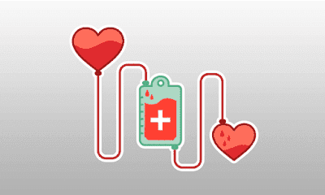](https://3.bp.blogspot.com/-wwaPUk1BZN4/W8rrOsoa7FI/AAAAAAAAAXg/YfPzaxSj_74D259L95_91OmDr6jMoLeowCLcBGAs/s1600/incentivizing-blood-donation.png)

**Not eligible for donating blood:**

**If you,**

1. had a affirmative antibody test for HIV (aids virus).
2. are suffering from situations like [Hemophilia](https://en.wikipedia.org/wiki/Haemophilia) , [Thallasemia](https://en.wikipedia.org/wiki/Thalassemia) or any other blood illness.
3. have used tranquillizer drugs by arterial route (injecting directly in the vein), even once.
4. had cancer.
5. ever had [myocardial infarction](https://en.wikipedia.org/wiki/Myocardial_infarction), [coronary artery bypass surgery.](https://en.wikipedia.org/wiki/Coronary_artery_bypass_surgery)
6. had a stroke.